This was originally written for a chapter in our daughter's book of 20 stories from men and women. However, this never came to fruition so I am taking this opportunity to adapt to sharing my
exciting journey over the last twenty years exploring holistic therapies through energy work and sounds.

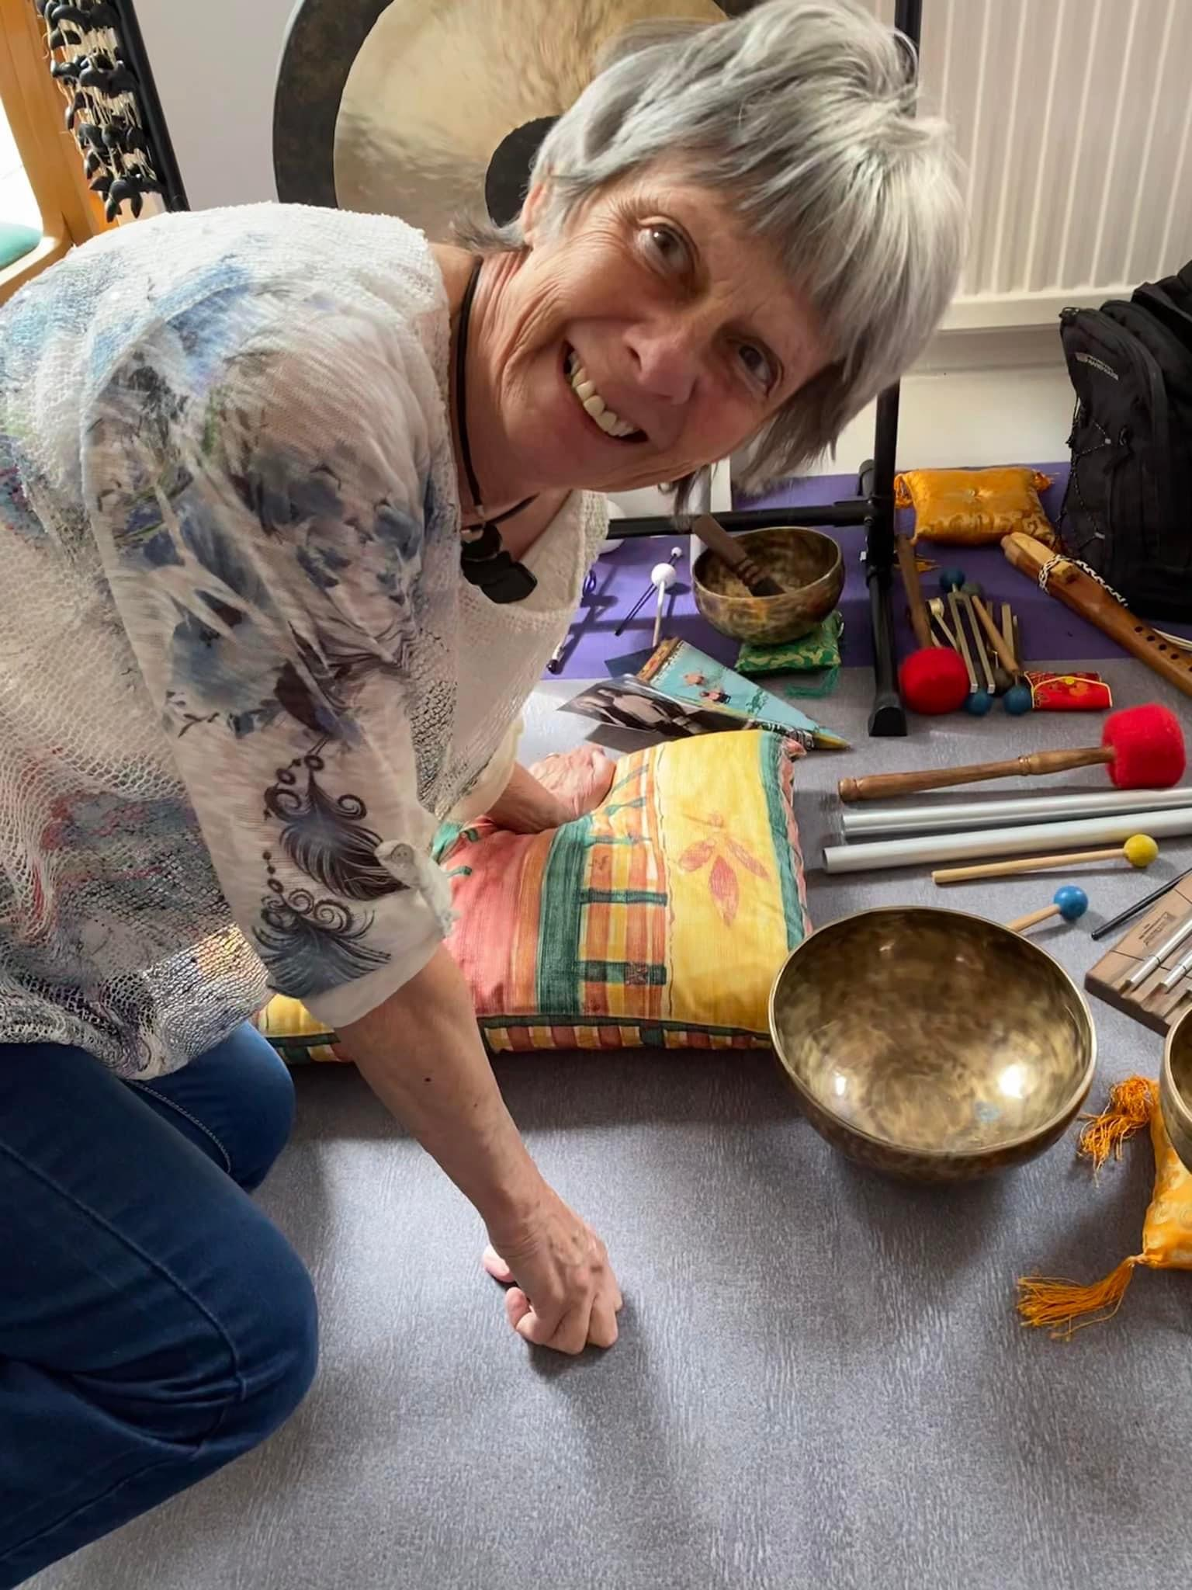

I am an energy healing facilitator, sound healing therapist and now retired holistic dance teacher who has found her purpose in life by learning about wellness, thus enabling her to support others. At seventy years old I learnt the bass guitar and have now formed my own group of like minded musicians.. Music and sound are what makes me feel alive.

Enjoy
SOUNDS GOOD TO ME

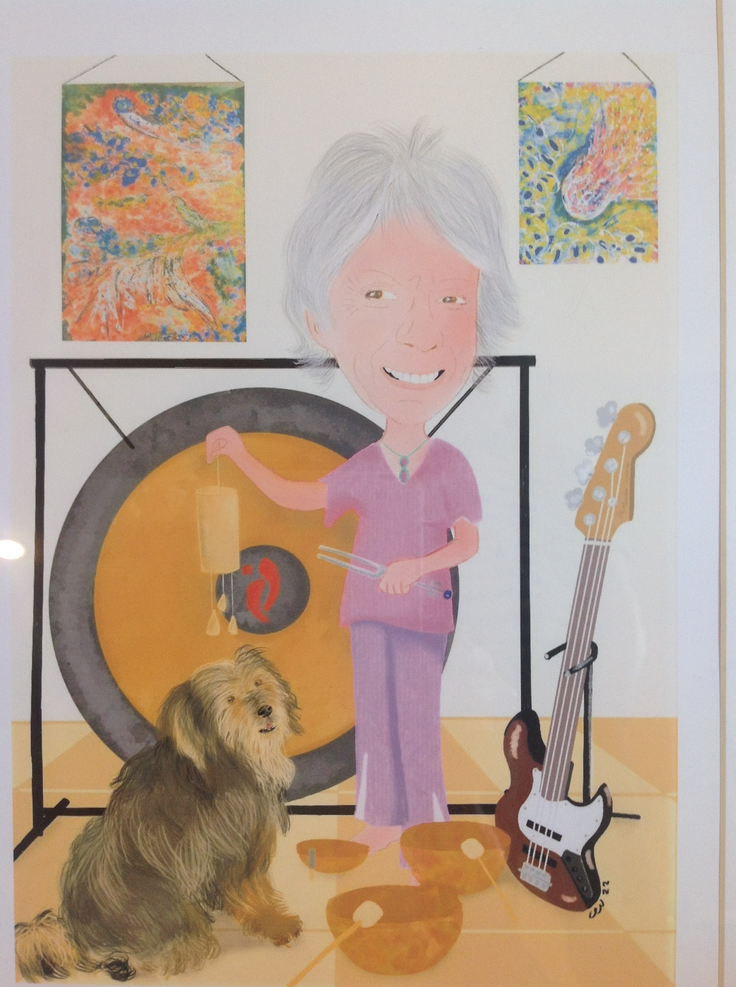

I have been fortunate enough to be able to enjoy life to the full without many limitations, supported by an amazing husband who I have known for sixty years. My story is my unique creation and everyone is unique in the way they wind their way through the journey which is theirs alone. There are so many invisible illnesses - mental, physical or emotional - that only the body of that person can have that relationship.

The brain loves to believe anything and every cell of the body can be affected. Only we can create the changes that are needed, however challenging that may be, and with only so much support from others. Just imagine if you really have free will, the power you could have to make your own choices.

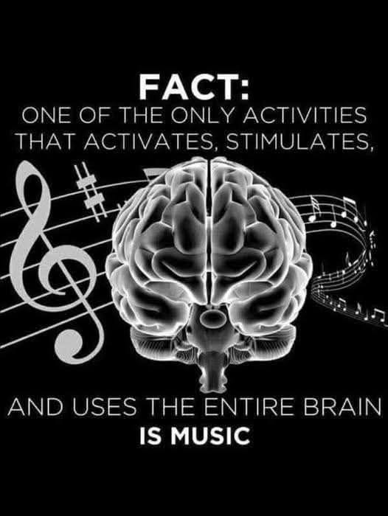

I think I generally lived life to the full, albeit not feeling enough self- worth. From everybody else's perspective of me I had a positive bubbly personality and came over as confident.

Many healing therapies to balance our energies can help in our self-care and once recharged can help others. The increased flow of energy can enable connection with others and what we give we receive tenfold. We are the only ones who know how our body is feeling, whether physically, mentally or emotionally and it is so important to listen to our body and see if there is anything we can change.

We only have one body, the most precious thing we own and we are the only ones that can nurture it. We need the courage to accept things we cannot change too. If we focus on fear or worry and the situation doesn't resolve we have wasted valuable energy. Trusting all will be well and expecting a positive outcome instead of worrying is better than any future agenda that may never happen.

We can often feel the burden of any negative situations and react. Sometimes it is hard not to be judgemental and not see things from the other’s perspective. As we travel through life's ups and downs we have the choice of offering empathy, observing without judgement or overwhelming ourselves with negativity. You can't control what other people do.

How often do we get caught up in the busy ness of life and can't seem to find time for ourselves. Sometimes it is wise to set aside however long to be in stillness and silence. When feeling nervous about an issue, sitting in silence and visualizing a positive solution can bring calmness and having a strong intention the situation can normally resolve itself naturally.

We probably can all remember a time when we were told we are not good enough and by reversing any negative thoughts we have the ability to reframe that belief.

Only recently I played my guitar in my first open mic and youngsters were coming up to me to say how amazing I was. Their perception of me was probably not mine but made me realize “Wow - I can do anything with the right intention. I am enough!” I am sure we have all had times when we underestimate our skills and others see us in a different light.

I am responsible for how I move forward in life and am unique in the way I go about it. Standing up to how we are feeling through our lives and not speaking the truth is certainly not healthy. How many of us try to keep the peace! One of the most common things we all do is make assumptions and this is certainly very true.

What do you truly believe and wish to see in the world and in your life? Write words affirming what you value; say them aloud, expressing gratitude for what has just come into being. Your voice has power, and you can change the conversation in your heart and in the world around you.

The value of cultivating a silent mind has been known for thousands of years. In India, people use meditation and the chanting of mantras to stop the internal dialogue. Others find stillness in walking in nature, yoga, dancing, running or swimming. It's up to you what you choose to keep balanced and focussed
May I be a healing energy

May I be of benefit to all

May my life enrich others

May I know what matters
And live in harmony with nature

MOVING TO HEAL WITH SOUND

The biggest impact on my life and confidence came from a holistic dance technique at a local Mind Body and Spirit festival and as soon as the music started with fabulous rhythms and moves, I was completely hooked.

My body loved the beat of the music and I felt alive. Have a listen to all types of music and explore what works for you to raise your vibrational energy. What rhythms and tempo makes you feel energized or calms you down.

The joy I received moving with freedom, letting go of my nervous disposition, could be expressed so much easier with the rhythm and beat of the music. I felt I was in my own little bubble completely at one with something greater than I had ever felt before.

As children we tend to dance without inhibitions but as we get older we can feel more shy and less confident in expressing how we feel. However, I expect some of you can move freely and joyfully and not feel at all worried or nervous or what others think about you. Senses can be awakened and inhibitions disappear. I realised that this was part of my journey to feel alive.
I choose sensation my body's way, unique to me

After four years of training in this new holistic dance way my whole being - physical, emotional, mental and spiritual - changed in a very subtle way. I must admit I was rather nervous when I started teaching but sharing with students the passion I was now feeling, witnessing them expressing their emotions and dancing with joy was so special. Again, sharing this by example is the best way to lead a class.

I can still feel the emotional response when receiving my certificates and it felt like I had received a huge gift to myself. Often when we give something special to ourselves we don't feel worthy but the best moments of our lives can be when we are authentic, when we can be ourselves and love what we do.

The confidence I gained from my achievement was the best feeling ever. We all have had these experiences but have probably not realised at the time.

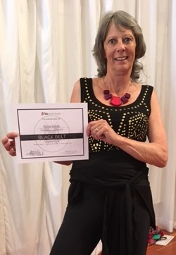

Finding our purpose in life to help people reach their greatest potential whilst living and sharing in an authentic manner can attract a new circle of friends. Dancing through the challenges of life enables the strength to nurture ourselves in wellness so we can nurture others.

Love your Body Love your Life

Over the years therapies have helped me grow in confidence and people started mentioning how different I seemed. Sometimes we don’t recognise the changes but again, others’ perceptions of us can be otherwise.

On one of my training sessions the trainer said if you get something wrong what is the worst thing that could happen to you? Why do we always beat ourselves up that we aren't good enough. Is it something from schooldays.

On the subject of perception, when living with intent and using the word D I E (Desire Imagine Expect), it can really bring to light how high our intention is to want something.

How often do we desire something but actually don't expect it to materialize? I have found this to be a valuable tool in living life with purpose without fear taking over.

Focus and intention are so important and sometimes we leave it too late to take action. Often when we do something when we least feel like it comes with the greatest shift in how we feel. With willpower comes results and manifestation can happen.

The intuitive mind is a sacred gift and the rational mind is a faithful servant.
We have created a society that honours the servant and forgotten the gift (Albert Einstein)

When you align your purpose to create a lifestyle that is uniquely and proudly yours, fuelled by inspiration and meaning, you increase personal power through attitudes, thoughts and self-love. There are four energy allies which can assist us in transforming our daily life
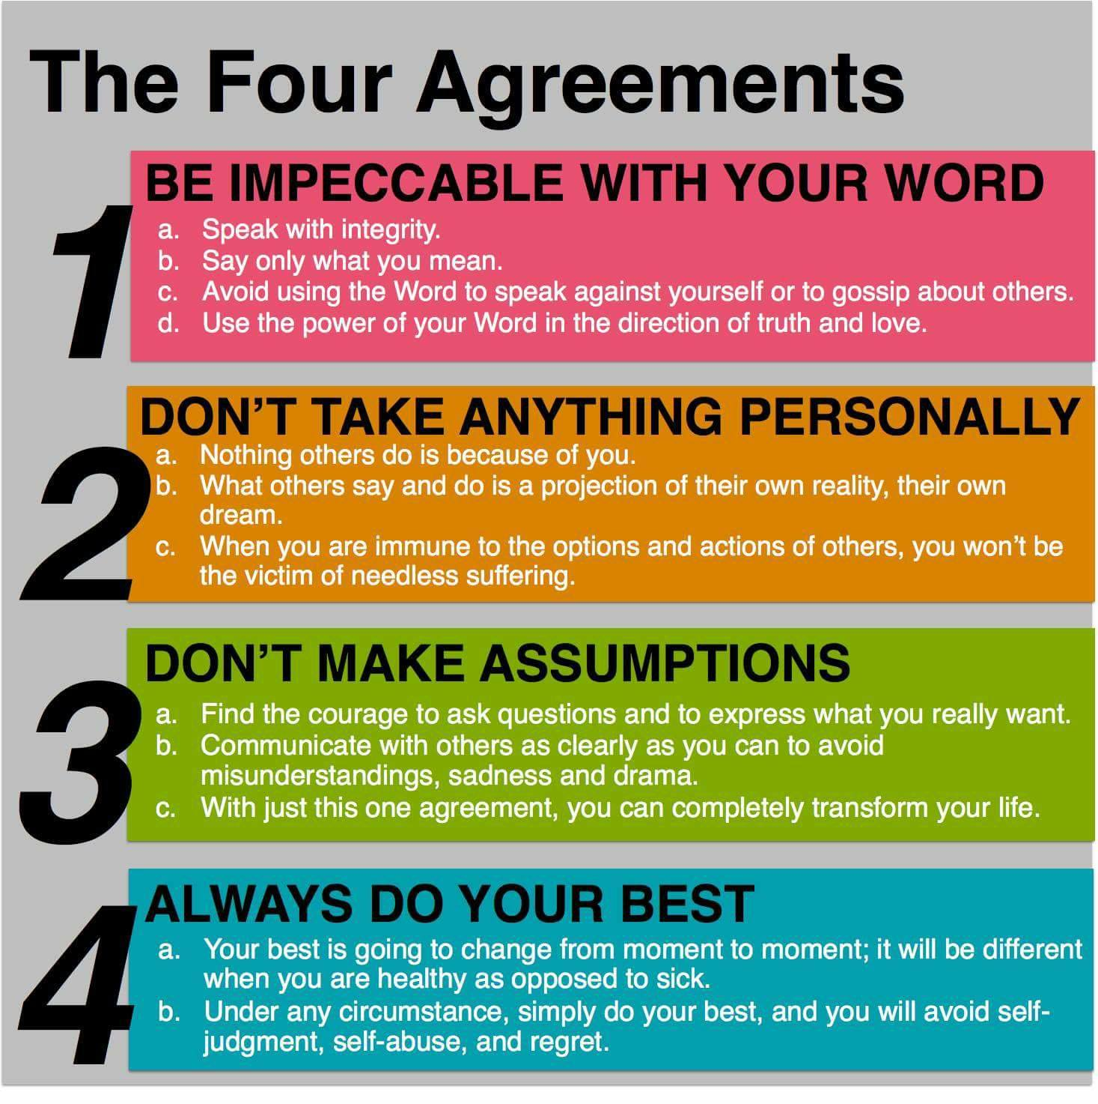

SOUND WILL BE THE MEDICINE OF THE FUTURE
(Edgar Cayce) (1877-1945)

A pivotal moment in my life was when I experienced the gift of receiving sounds through alternative ways, in this instance tuning forks. The two pronged fork is hit with a striker and held against the ear. Depending on the length of the fork the vibrations can sound very deep to very high.

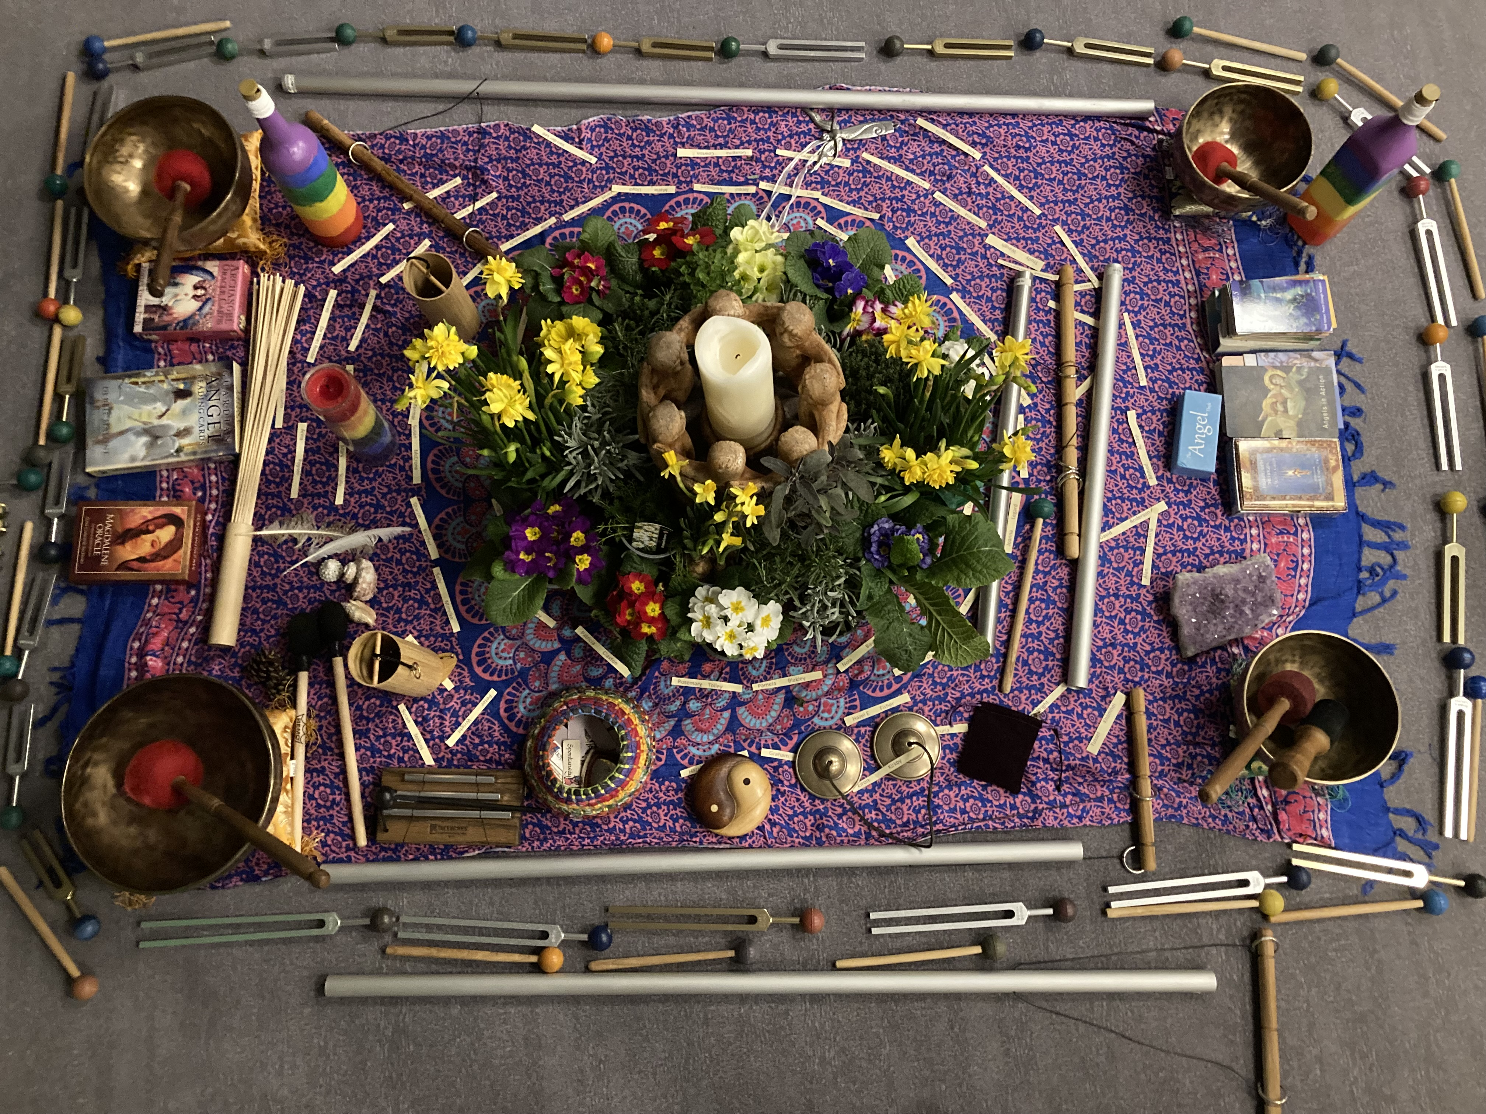

The vibrations can be very calming and an opportunity to be in complete stillness. There is evidence that tuning forks have been around for hundreds of years, as depicted on ancient stone works of art.

The whole universe is nothing but sound
The body is nothing but rhythm
The universe is nothing but rhythm

It has been scientifically proved that sound travels through water five times more efficiently than through air. The human body is made up of 70% of water so makes a good conductor of sound.

It massages tissues, alters cells, improves blood circulation, metabolism, pulsing of nervous system and endocrine glands. Blood count also increases when sound is given compared to being in silence. Modern medicine now uses sound waves to break up kidney and gallstones in the body.

Dr Masaru Emoto, a Japanese scientist, has written a book called 'Messages in Water' showing that the simple act of words, thoughts, prayer and intention can change the molecular structure of water. Classical music produced beautiful crystals of different colours. Heavy metal music produced patterns that looked like a crystal exploded into a thousand pieces.

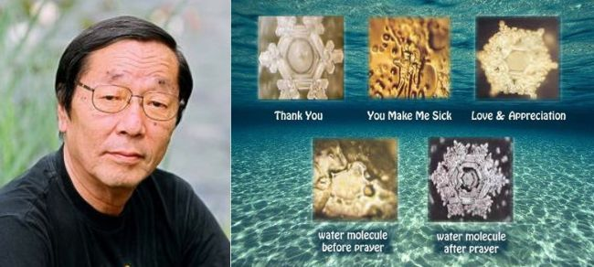

Imagine what patterns your blood cells would like when you are very angry compared to being in harmony. If we hold a negative thought or feeling for long enough it may manifest on the physical level as an illness.

How often when hearing some traumatic news do we feel that feeling in our stomach.

There is also evidence from John Stuart Reid with his music-blood experiments, financially supported by the College of Sound Healing, that show red blood cells changing after a sound bath with all the variety of vibrations. They are not so clogged together and are dancing more.

Damaged cell membranes can repair within 20 minutes of immersion in music so a sound bath session would be very healing.

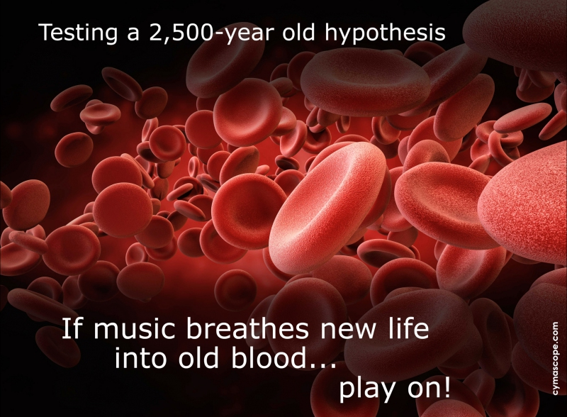

The Om vibration is the sound the baby hears in the womb and also when end of life comes to enable letting go. It is the frequency of the Earth and the amplifier for all the other tuning forks.

The Om is a frequency that helps to balance the right and left hemisphere of the brain, quietens chatter and helps sleep. Brainwaves can be entrained within minutes.

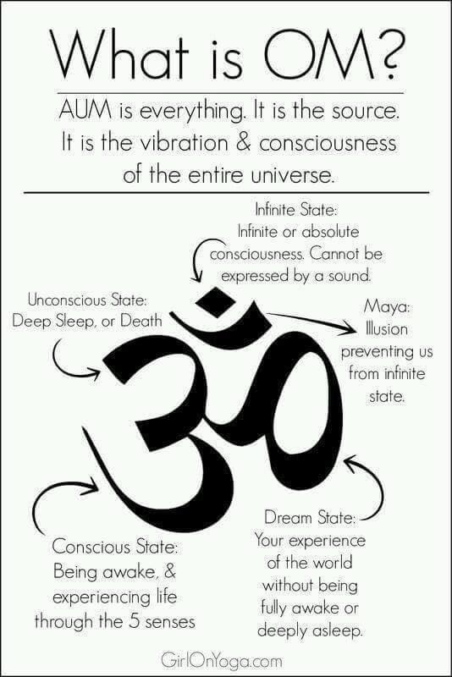

The sound of the frequency travels into the ear and into the vagus nerve and is called the wandering nerve as it travels all around the body/organs meeting at the heart area. The ear is the orchestral conductor of the entire nervous system. Even if someone is deaf the energy can still travel! Some people feel tingling sensations around their body and toes twitching!

Humming is very beneficial to the vagus nerve and so simple to do. The vibrations stimulate the muscles in the back of the throat and activate sensory receptors in the ear. These travel along the vagus nerve causing it to send signals to the brain that promote relaxation and reduce stress levels.

The body has a network of energy lines called meridian lines which correlate with different organs. Along each one are acupuncture points where acupuncturists insert very thin needles in. Alternatively weighted tuning forks are just as effective placed on areas of need or reflexologists can massage these points on the feet or hands.

Every organ has points to work on and charts that show them are so interesting. When having a reflexology session some people feel tingling in areas of their body and this happens too when using tuning forks.

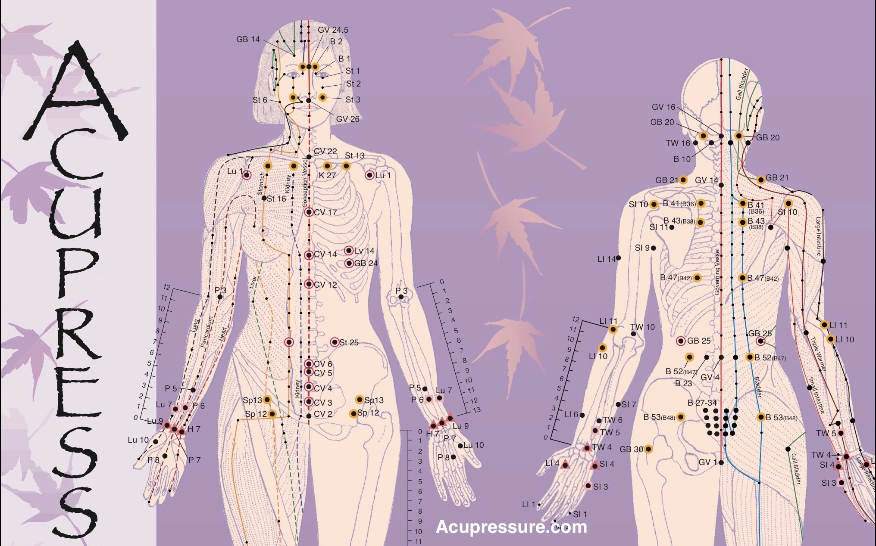

The thymus gland area is a great place to use a weighted tuning fork and helps stimulate the immune system. The thymus gland is the first organ to be affected by mental attitudes and stress.

It can shrivel in size in response to acute stress such as an infection and is the primary immune fighter of illness. It produces T-cells whicy help prevent the spread of viruses in the body Listening to music wil also instantly raise the level of thymus activity.

Have you ever heard the sound of a didgeridoo and felt the feelings of one of the deepest vibrational sounds in your body? Children would be fascinated listening to this.

Even lower than this would be the sounds from an elephant and the highest from dolphins, frequencies that are opposite bright and shrill. We often resonate with whatever our body needs. Have you ever heard the intriguing sound of the dolphin?

The Body is nothing but Rhythm
The Universe is nothing but Rhythm

The job of a healer is to harmonize your Rhythms with the Rhythms of the Universe
'Dr Ram K. Bhosle (1918-2006)

(massage therapist who practised classical music and dance to refine his use of rhythms and to master greater sensitivity to vibration through his sensitive vibrating fingers)

So many issues in life are due to stress and this can alter vibrations to all the cells in our bodies. We are 70% of water via our blood so it makes sense that vibrational energies can change the way our bodies feel. It feels similar to the way some people feel after a massage, so relaxed and calm.

SOUND OF MUSIC

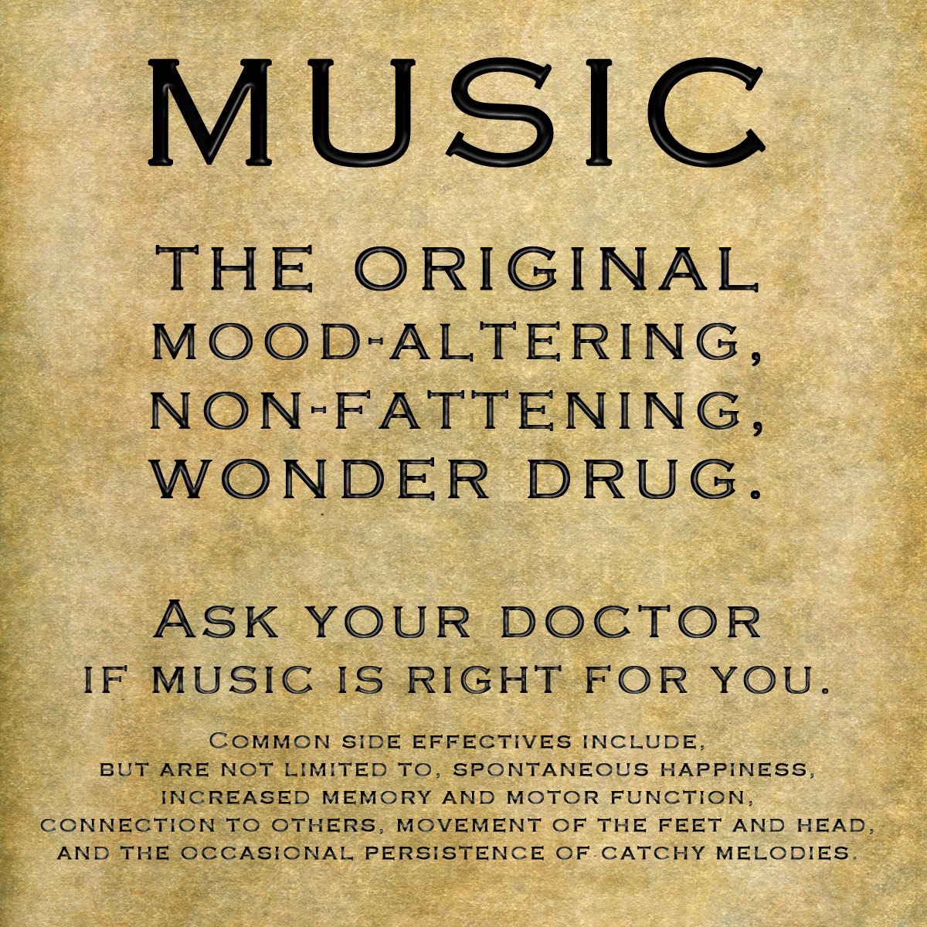

The vibrational energies from any instrument can also help to keep us grounded and free from fear. We could liken this to an instrument out of tune and when we correct it can sound so harmonious. Aim for the will power to keep yourself in a relaxed state and the confidence to walk your journey the way your heart feels not your head. It can be interesting when logic gets in the way and we think we know what we need.

Traumatic experiences can dramatically affect our whole body and it is not only physical issues that can knock us out of balance. If we receive bad news or someone says something unkind to us this can feel like being hit in the stomach. Emotional or mental trauma can also affect the body.

A healer is not someone that you go to for healing,
a healer is someone that triggers within you
your own ability to heal yourself

There have been many traditions across the world, for example, Native Americans used drums and rattles and have a song for each stage of life. Lyres and harps were used years ago for therapeutic purposes and the Greeks believed music had the power to heal body and soul.

It is quoted that Beethoven said at the end of his life “My doctor can't do anything more for me but music can.”

The gong is the most powerful instrument for healing with wide spectrum of harmonics that wash over the body. It can activate the parasympathetic nervous system and may even release emotional pain and mental blockages. The sounds emitted can sound like whales or dolphins and very ethereal.

The gong's sounds and vibrations move us from our normal awake state (Beta) to a more relaxed and calm (Alpha) state, then on to a restful (Theta) state and finally to a deeply relaxing meditative (Delta) state.

Drumming circles are very energizing when playing with others with different rhythms and tones. I offer these sessions in my home and everyone feels so energized afterwards. It is a beautiful way to connect to the community as it helps break down barriers between people.

University of Oxford psychologist Robin Dunbar discovered a strong association between group drumming and endorphins which are the body's natural opiates, increasing pain tolerance.

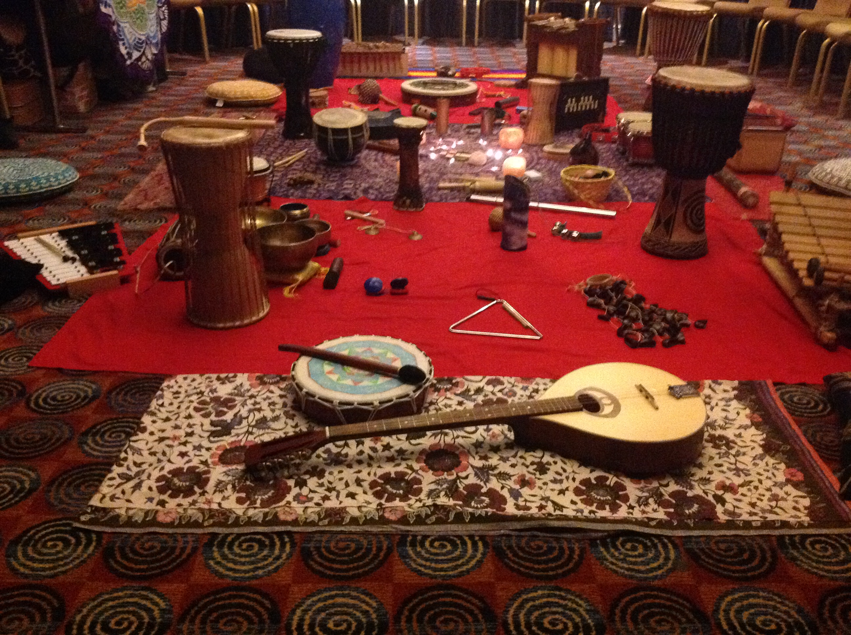

The drum entrains the heartbeat with regular rhythm and repetitive drumming slows down brain rhythm, reducing heart rate helping relaxation. Have you ever experienced the vibrations from a deep drumming sound in your chest?

Singing bowls offer a deep sense of relaxation and peace. The pulsation produces harmonics that penetrate deep within and can be placed directly on the body for more effect.

Some may have experienced a sound bath. (You don’t get wet!) In this type of session the clients lie on yoga mats with blankets and pillows and free the mind of any stressful thoughts. I walk round the room with the singing bowls, chimes, drums and sound over their bodies. I always finish by using the bowls with the lowest vibration for grounding along with a deep drum and maybe a rain stick.

I find that most of my sound bath participants are in a deep relaxing stage for a very long time after the end of the soundings. Many have muscle flinching, see colours and sense tingling in their bodies.

A lot of snoring goes on too but I always say the body is still benefiting from the sounds. The gift to themselves of being in stillness for an hour bathed in a range of beautiful sounds is so special.

The mixture of vibrations produce a concert of sound over the body and into the energy field surrounding the body. Stagnant energy is cleared, bringing the nervous system, immune system and organs into harmonic balance.

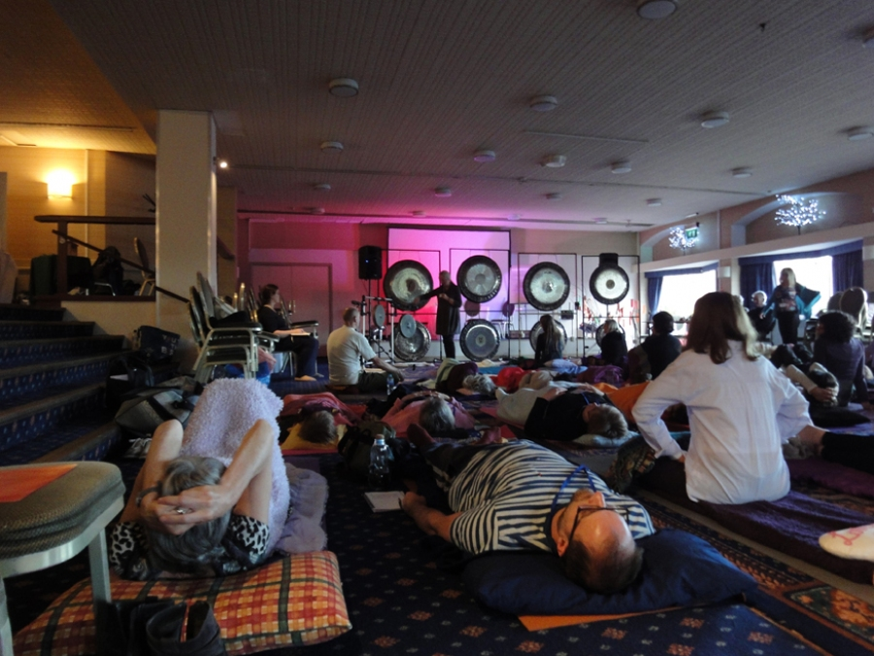

There are certain instruments that can aid different organs in your body due to the vibrational frequencies. Drums are good for the kidney and bladder. Metal instruments are beneficial for the lungs.

Wooden instruments like flutes nourish the liver. Stringed instruments like cellos, violins connect to the heart. Clay whistles are associated with the stomach and spleen.

Harps and lyres were used for therapeutical purposes as far back as 324 BC. The Greeks believed music had the power to heal body and soul.

SOUNDS FROM YOUR VOICE

As someone who never had a strong voice for singing and also lacking confidence when young, I found that joining in with a local gospel choir brought out what had been hidden vocally for so many years.

The human voice is an important sound healing therapy as it adds elements not found in any other instrument and is another way to express yourself and connect to others.

Whether singing alone or with others it can lift the spirit, especially if the words resonate with you with whatever is going on in your life. Along with the rhythm, melody and beat of the song it can either be stimulating or calming.

It may cause someone to start crying when the words hit an emotional issue at a subconscious level. I remember when visiting my daughter in Australia my gospel choir singing “Hold On just a Little While Longer” as I was supporting her at the hospital.

This can be such a great support from your community. On the other side of the spectrum words at a wedding can be so uplifting and focused on the happy occasion when loved ones gather to celebrate the union.

Have you ever noticed how you feel united and connected with a group of like-minded people? We are creatures of connection through energy.

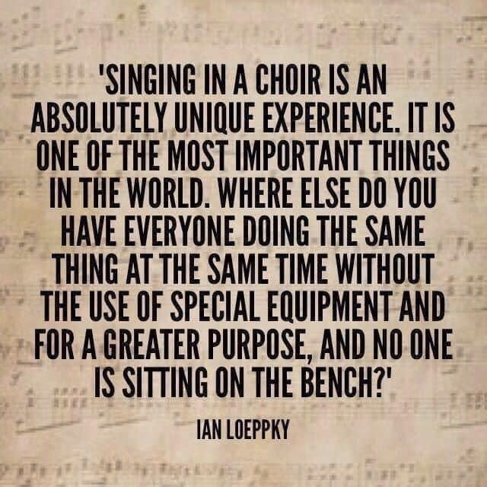

What music makes you feel joyful, happy, excited, comforted? Have you ever listened really deeply to all that is going on.

Many neuroscientists believe singing can have a physical healing effect. Singing uses right hand side of brain, especially when singing by ear or by memory whereas speaking uses the left hand side. Some autistic children who are unable to speak are able to sing.

There has been a case of a lady with Parkinsons who remained motionless most of the day who played the piano beautifully with freedom and normality.

ECG (electrocardiograph) recordings would usually register coma-like stillness but then became normal (Oliver Sacks British neurologist)

Try singing loudly in the car (or hum) to get your voice going before a social function. Singing helps posture, relieves stress, improves mental alertness, concentration, relaxes muscles and releases the same feel-good brain chemicals as sex and chocolate!

Music can reduce negative emotions, especially upbeat tunes that can take your mind off what stresses you and helps you feel more optimistic and positive. Relaxing music reduces nervous system activity by decreasing anxiety and can help improve the mood.

Songs most effective for music therapy patients a UK study found Queen's clasic 'We will Rock You' came first followed by 'Three Little Birds' by Bob Marley and 'Another Brick in the Wall' by Pink Flloyd

Music speaks what cannot be expressed, soothes the mind and gives it rest; heals the heart and makes it whole, flows from heaven to the soul – Author Unknown

PLAYING SOUNDS I LOVE

I have always been intrigued with the deep vibrations of a bass guitar and have found this is the instrument I resonate with and love most. As I only started playing at seventy years of age I am so proud of where I am and the amount of passion I have for this instrument. I wish I had learnt it years ago. We all resonate with different pitches and eventually find an instrument or music to suit our own frequencies.

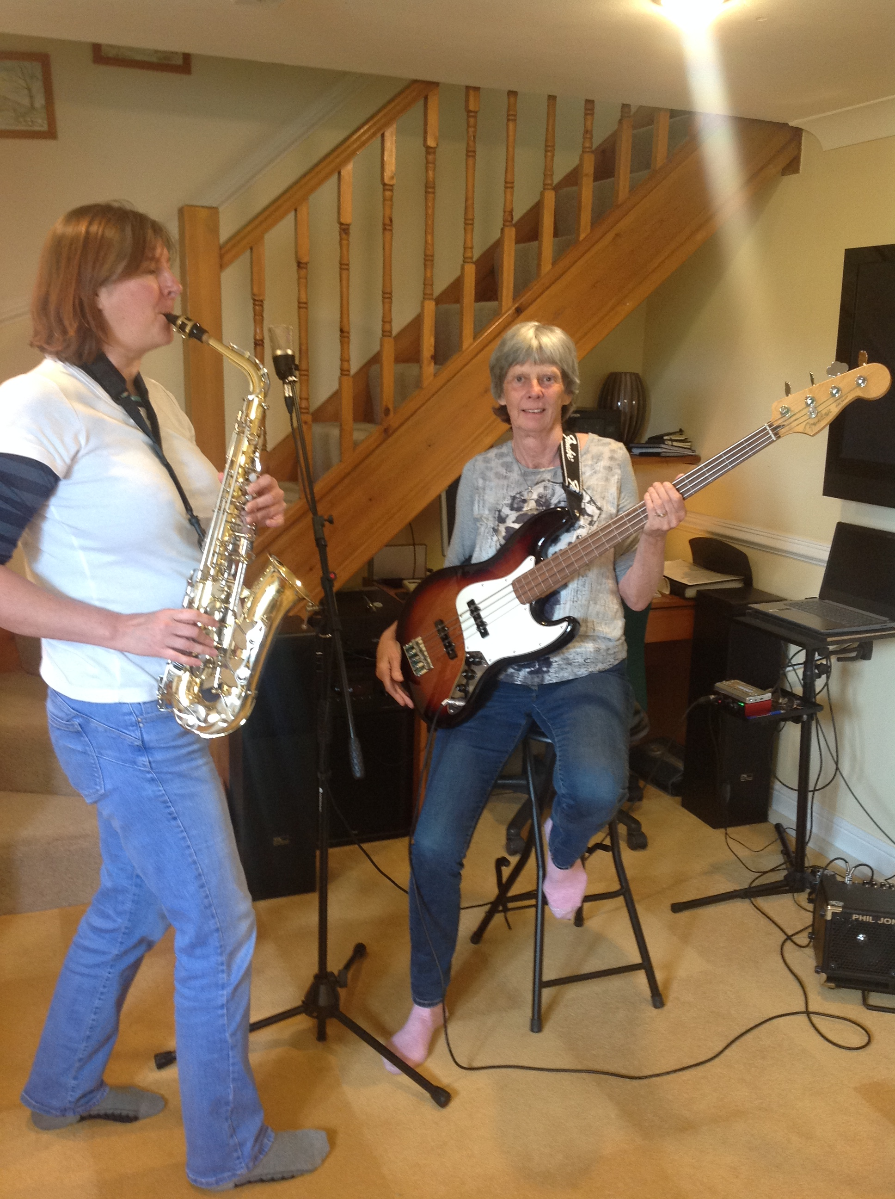

I was lucky enough to have piano lessons from the age of 4 and this has given me such a good start in my musical life. For many learning an instrument has been a traumatic time. As one of my friends told me he had the lid of the piano slammed down over his hands when he played a wrong note!

Others have been told 'you'll never be good enough' or ' you can't sing' . So many of my gospel choir members have been told this. If you were born in an African tribe everyone would sing. It is part of our birthright to sing.

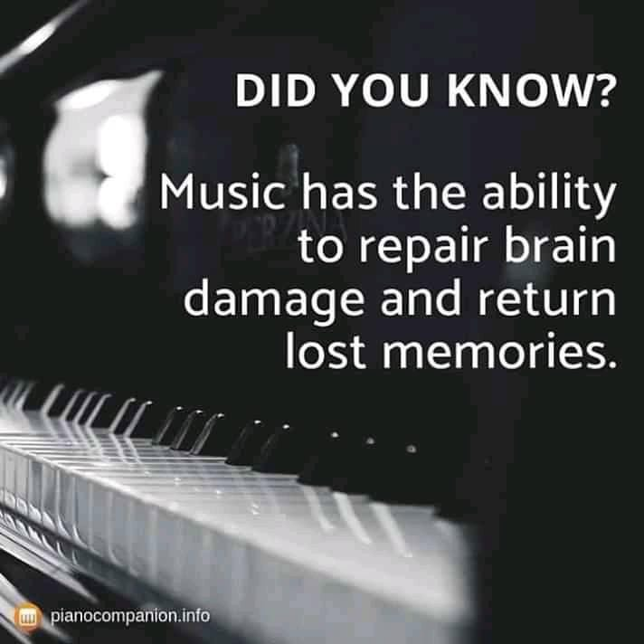

Playing the piano can be so creative and can create a healthy body, mind and life. It definitely improves hand-eye coordination in the young and even more so if learning an organ with different keyboards and foot pedals. I had a go on one and it really is a massive brain workout doing feet and hands together.

Research indicates that children who have had a few years of piano study under their belts could remember 20% more vocabulary words than their peers.

Research has also shown that piano lessons for older adults has a significant impact on increased levels of Human Growth Hormone, which slows the adverse effects of ageing. I am all for that!

The high frequencies of the violin are at the other end of the range of the piano and apparently the violin is one of the hardest to play. Einstein said the reason he was so smart was because he played the violin. He loved the music of Mozart and Bach the most. Some consider that the guitar requires the most intelligence to play and is the smartest and coolest

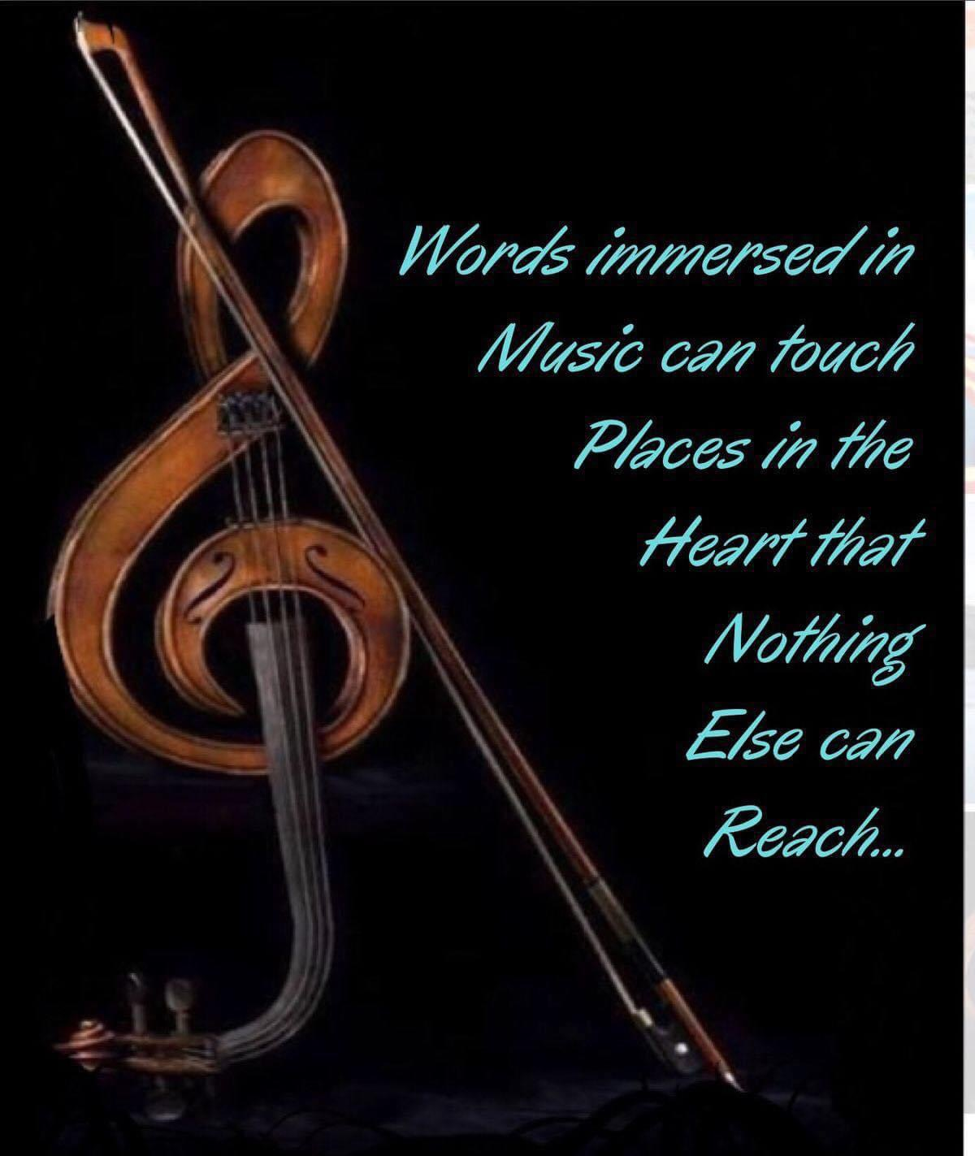
The human body is wired to be exquisitely sensitive to sound. Playing an instrument requires reading, listening, movement, memory and emotions so all of the areas of the brain spring into action, from the frontal lobe to the cerebellum and several regions in between.

It's a whole brain workout! (Jonathan Burdette, MD, professor of neuroaudiology at the Wake Forest University School of Medicine who studies the impacts of music on the brain) Like the muscles in your body, your brain will lose strength if you don't use it and I know nothing that uses your brain more than playing music.

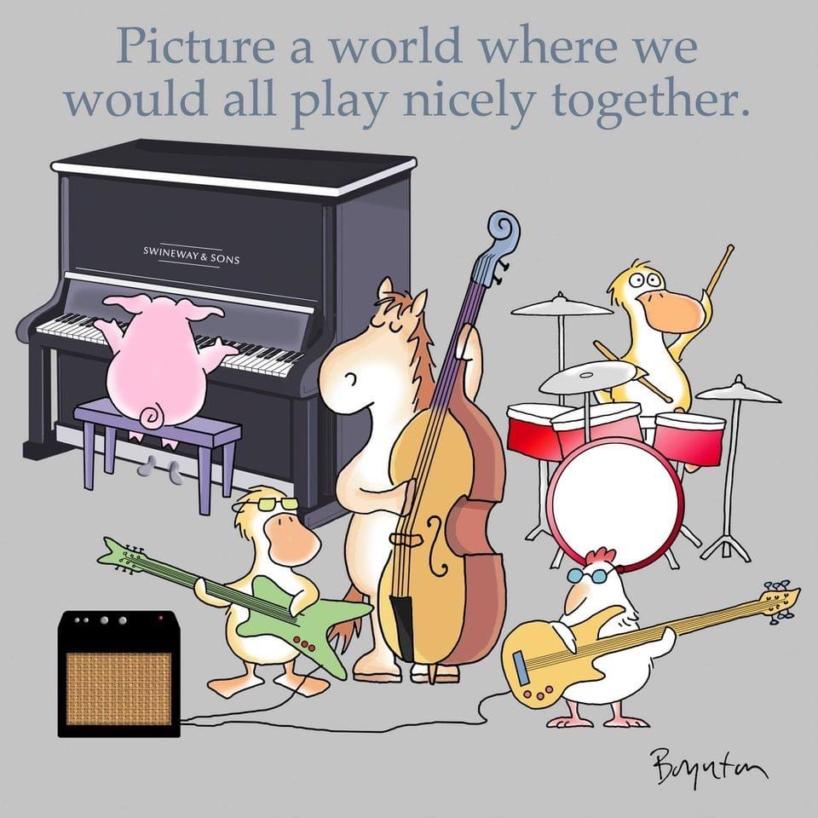

LISTENING TO THE SOUNDS OF MUSIC

Martin Luther King said “My heart which is so full to overflowing has often been solaced and refreshed by music when sick and weary.”

Don Campbell in his book “The Mozart Effect” explains how music, particularly that written by Mozart, has all kinds of beneficial effects for human health. Some research suggests that listening to Mozart helps us to improve our powers of concentration as classical music works on the whole brain.

As violin music has the richer, higher frequencies the sounds especially from Mozart's more youthful compositions are more appropriate for children. Mozart started playing extremely young and by the time he was five was already writing sophisticated compositions.

Dr Thomas Verney cites recent scientific evidence that when pregnant mothers listened to Mozart and Vivaldi their babies’ heart rates invariably steadied and kicking declined. Rock music drove most foetuses to distraction and they kicked violently.

According to the Indiana University Human Intelligence website, some scientists believe that exposing young humans to music, even while still in the womb can increase spatial awareness, reasoning and overall intelligence.

Neurodiversity (differences in the way our brains work) can be stimulated by listening to instrumental songs. When children especially have tough days, slow soothing songs can help calm the body and prevent meltdowns.

In the UK sound sessions are being introduced to young children in nurseries and primary schools. It is beautiful to watch videos or see photos of them exploring the different sound tools and to see them lying down enjoying the time to recharge. Wouldn't that be a fantastic part of childrens’ lives!

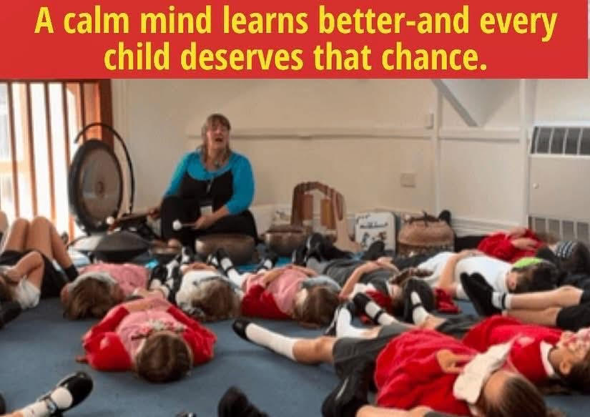

Listening to music may help those with ADHD, Parkinsons disease and other neuro degenerative diseases as it can increase dopamine, a neurotransmitter and certain ADHD symptoms may be linked to lower dopamine levels. One piece of music in particular has helped so many (Barber's Adagio for Strings)

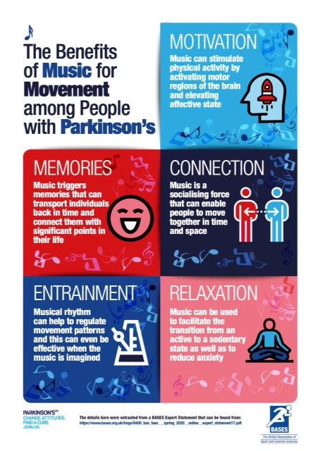
Music therapy is particularly effective with those with Alzheimers disease and dementia, autistic disorders, stroke victims and even prisoners. A study of a group of women in a prison in Israel who all participated in a choir showed they experienced a sense of community and togetherness as a result.

The music helps brain messages to organize and flow and puts the brain to a higher gear.

Professor Clive Holmes from Southampton University studied effects of live music on dementia patients. He said “Suddenly they came alive – some hadn't spoken for three years.” Popular classics of their era would stir them to dance or sing along with the music, like 'The Blue Danube' or Glenn Miller's 'Chattanooga Choo Choo'.

With those suffering from Parkinsons Disease the power of music can help relax muscles and release tension in back, neck and throat (where swallowing is affected too). Singing in your head or out loud can be a way to regulate walking and improve gait (some of the main symptoms of the disease. The brain is less able to process automatic movement like swinging the arms when walking or moving one foot after another.

Have you ever had goosebumps or chills when listening to a piece of music, as if heard from the soul. If so your brain is reacting the same way as it would to delicious food or a psychoactive drug such as cocaine, according to scientists.

Listening to music can reduce depression by up to 25% according to a paper in the Journal of Advanced Nursing.

When we listen to a certain type of music there is a release of the brains reward chemical dopamine, the feel-good hormone, according to results of experiments published in Nature Neuroscience Jan 2011.

It's hard to put into words the impact of the perfect lyric, melody or contagious beat that moves you in an unexpected way. I am sure many will have memories of a song that provokes a time in life that was either very happy or maybe very sad. Songs from the war days still stir those that had little time to enjoy such music and would have been so appreciated.

If music be the food of love, play on!
William Shakespeare (Twelfth Night)
It was believed that music was a tangible force that had the power to magnify and enhanced emotions and quite literally 'food for the soul.’

Listening to music increases the body's metabolism and produces an effect on the pulse and blood pressure as well as affecting emotion.

It has been proved by doctors that music played in operating theatres reduces pain, anxiety and recovery time. It is gaining more acceptance in the medical field now and also treating veterans suffering from post traumatic stress disorders.

Hospitals are starting to use harpists to calm patients and found the instrument eased pain. The NHS (Royal Brompton Hospital) is set to become the first trust to take on harpists.

The range of vibrations emitted by plucking the strings affect the body's nervous system. It can alter brain patterns, slow heart rates and increase oxygenation in blood.

The only activity that activates, stimulates and uses
the entire brain is music
It also repairs brain damage and returns lost memories

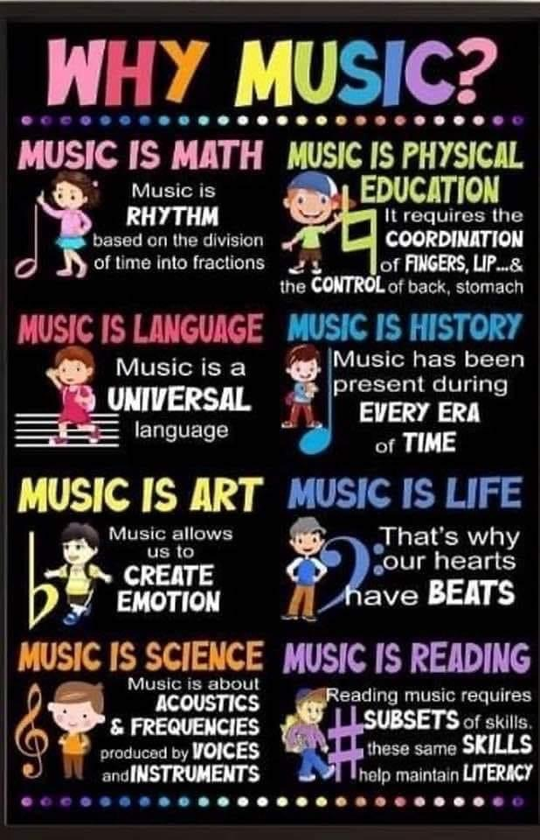

As I mentioned earlier, music and sound is what makes me feel alive and is the most beneficial and life changing part of my journey. I love playing music with others as it can be so rewarding and I find time flying by when I am having fun. It can also be great improvising and creating music with freedom.

How many musicians are taught to play a song they don’t enjoy or the way the composer wrote it? Explore and make music that resonates with you and that feels and sounds good to you. Makes subtle changes to your life through the vibrations of your heart and soul in whatever way suits you. You are never too old to learn an instrument or sing!

Music expresses that which cannot be said and on which it is impossible to be silent. Music washes away from the soul the dust of everyday life. Music doesn't lie. If there is something to be changed in this world, then it can only happen through music.

When an education is wrapped in music it is strengthened

When a life is wrapped in music it is comforted

When a community is wrapped in music it is connected

We should wrap our schools, our homes and our communities in music.

What a world that would be !

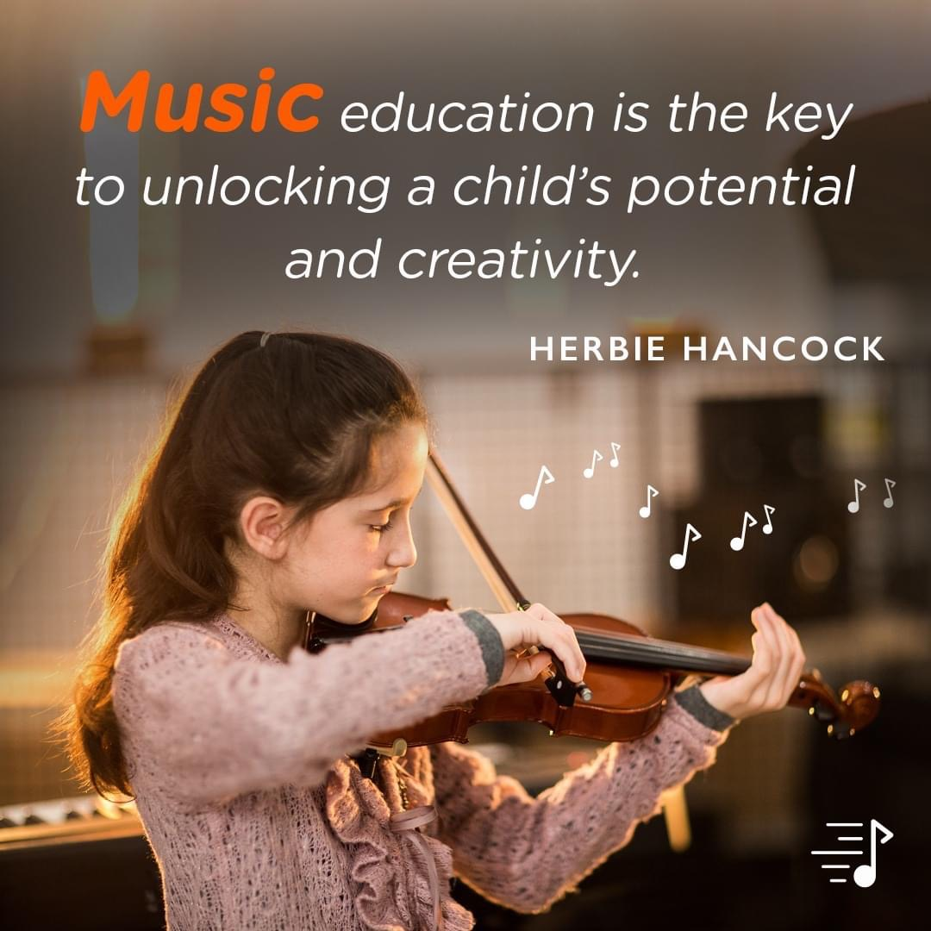

Recommended Reading

The Nia Technique, new Body, new Life by Debbie and Carlos Rosas

Your Body's Many Cries for Water by Dr F Batmanghelidi

A Practical Guide to Vibrational Medicine by Richard Gerber MD

Tuning the Human Biofield – Healing with Vibrationbal Sound Therapy by Eileen Day McKusick

Music as Medicine, particularly in Parkinsons by Daphne Bryan

